# Assignment - 4

**Objective:**

Write code and connections in wokwi for the ultrasonic sensor. Whenever the distance is less than 100 cms send an "alert" to the IBM cloud and display in the device recent events.

# Circuit Diagram:

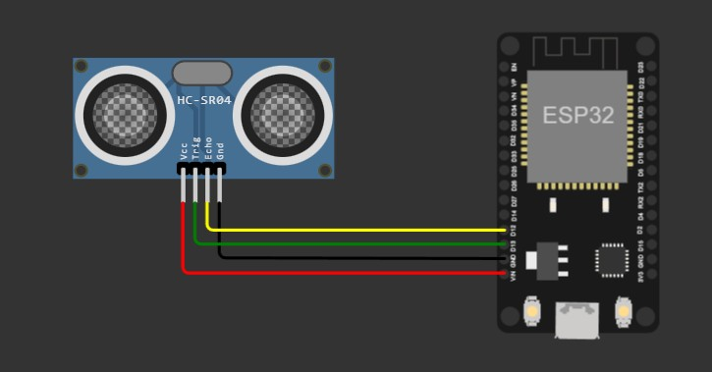

# OUTPUT:

